**1] Successfully created the VPC**

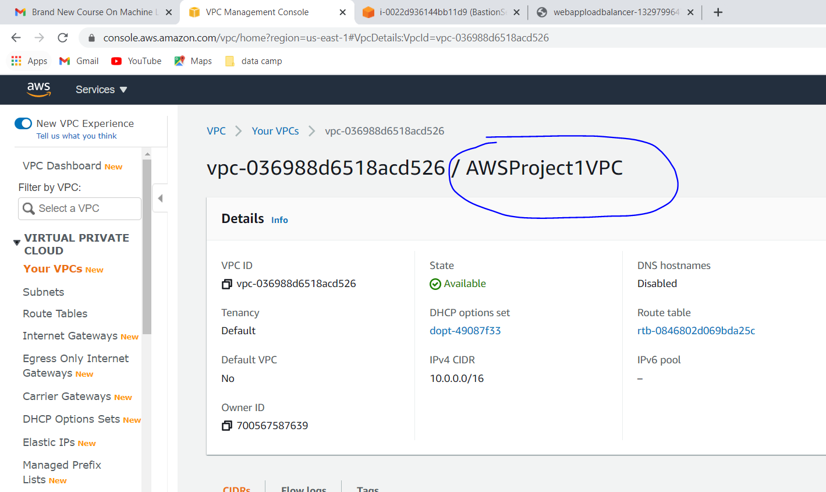

**2] Successfully created the pubic subnet and private subnet and 3 public subnets for multiple AZ**

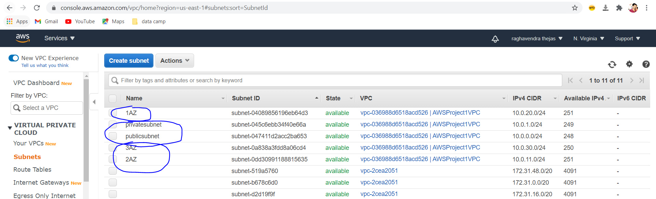

**3] Successfully created the IGW and attached VPC**

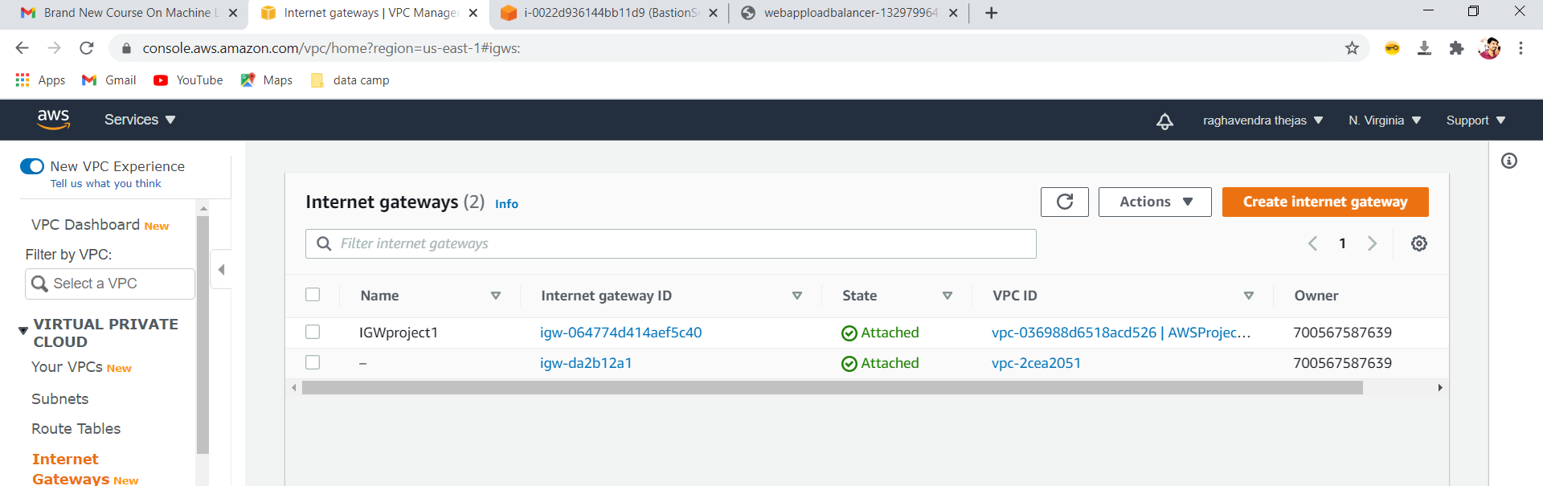

**4] Successfully created the route tables**

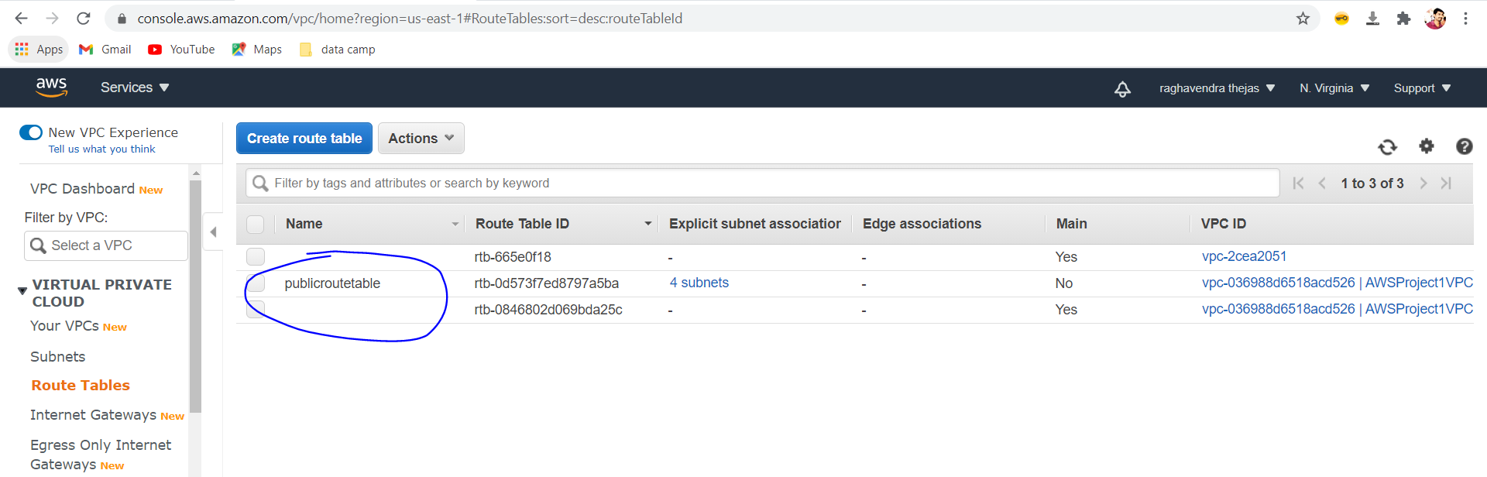

**5] Successfully created the NAT gateway**

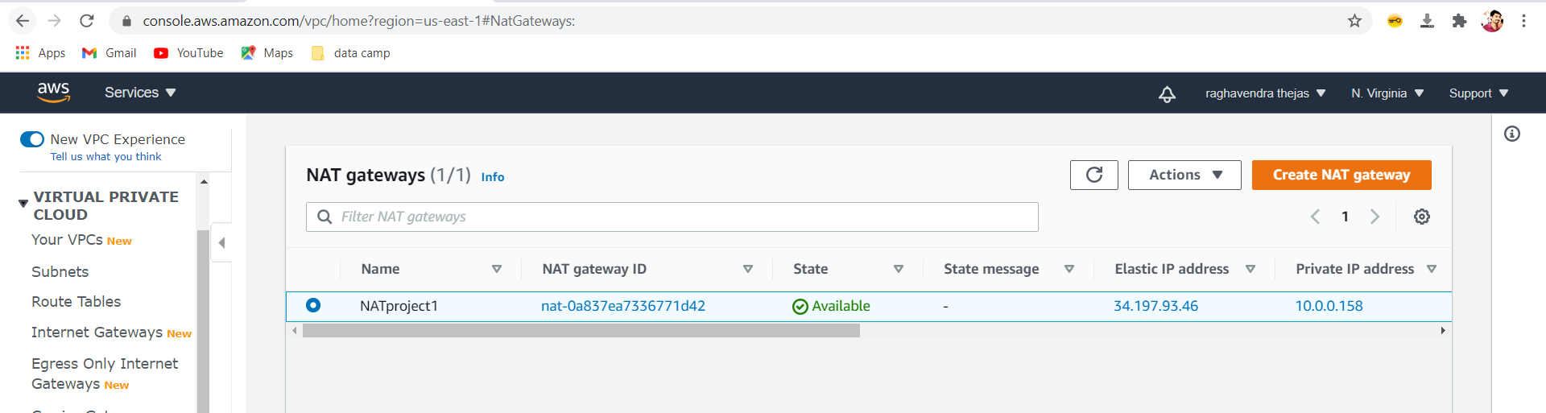

**6] Successfully created the Bastion Server**

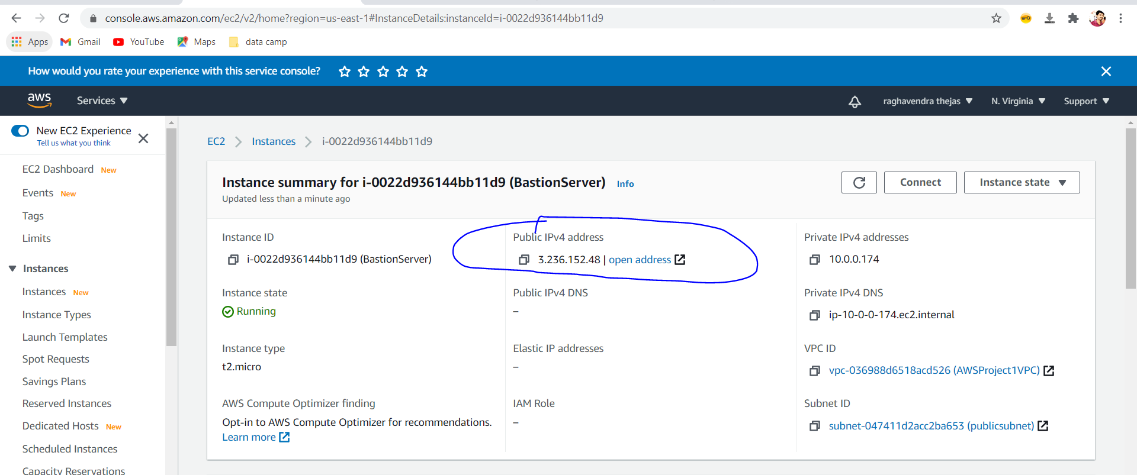

**7] Successfully created the Load balancer SG, webserver SG and Bastion SG**

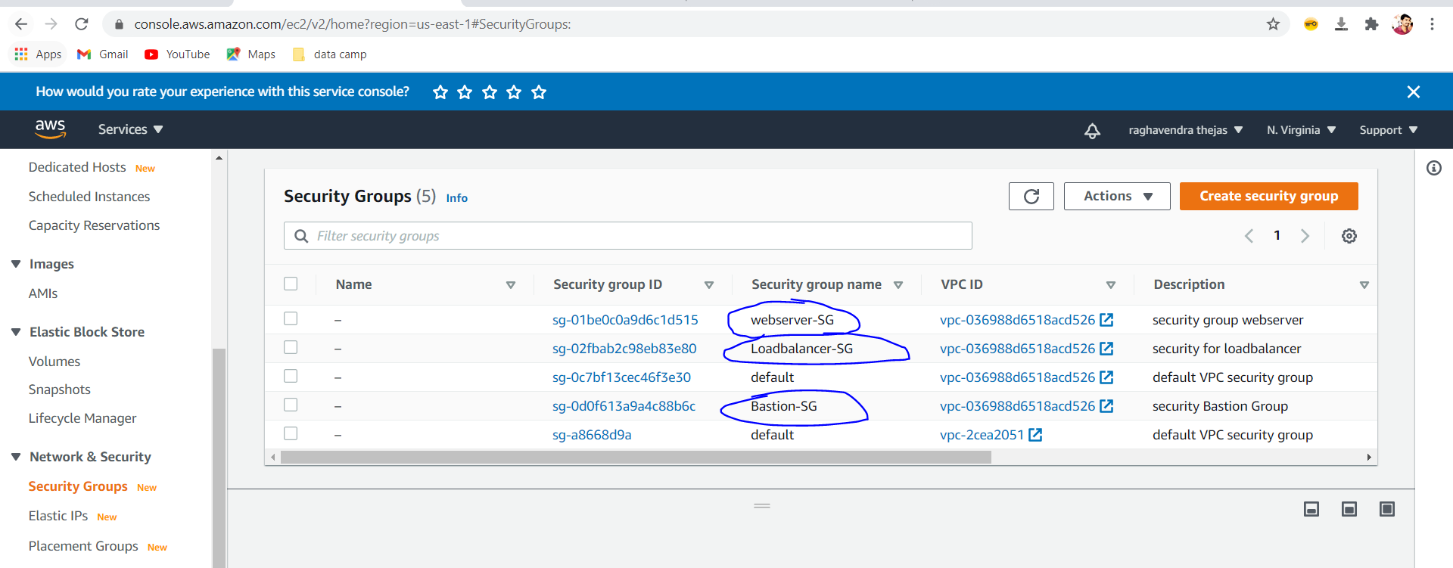

**8] Successfully created the webserver1,webserver2**

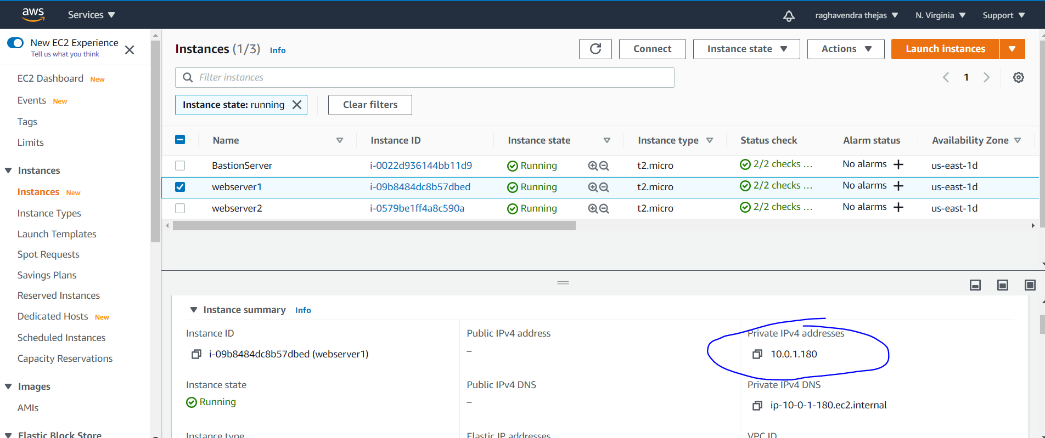

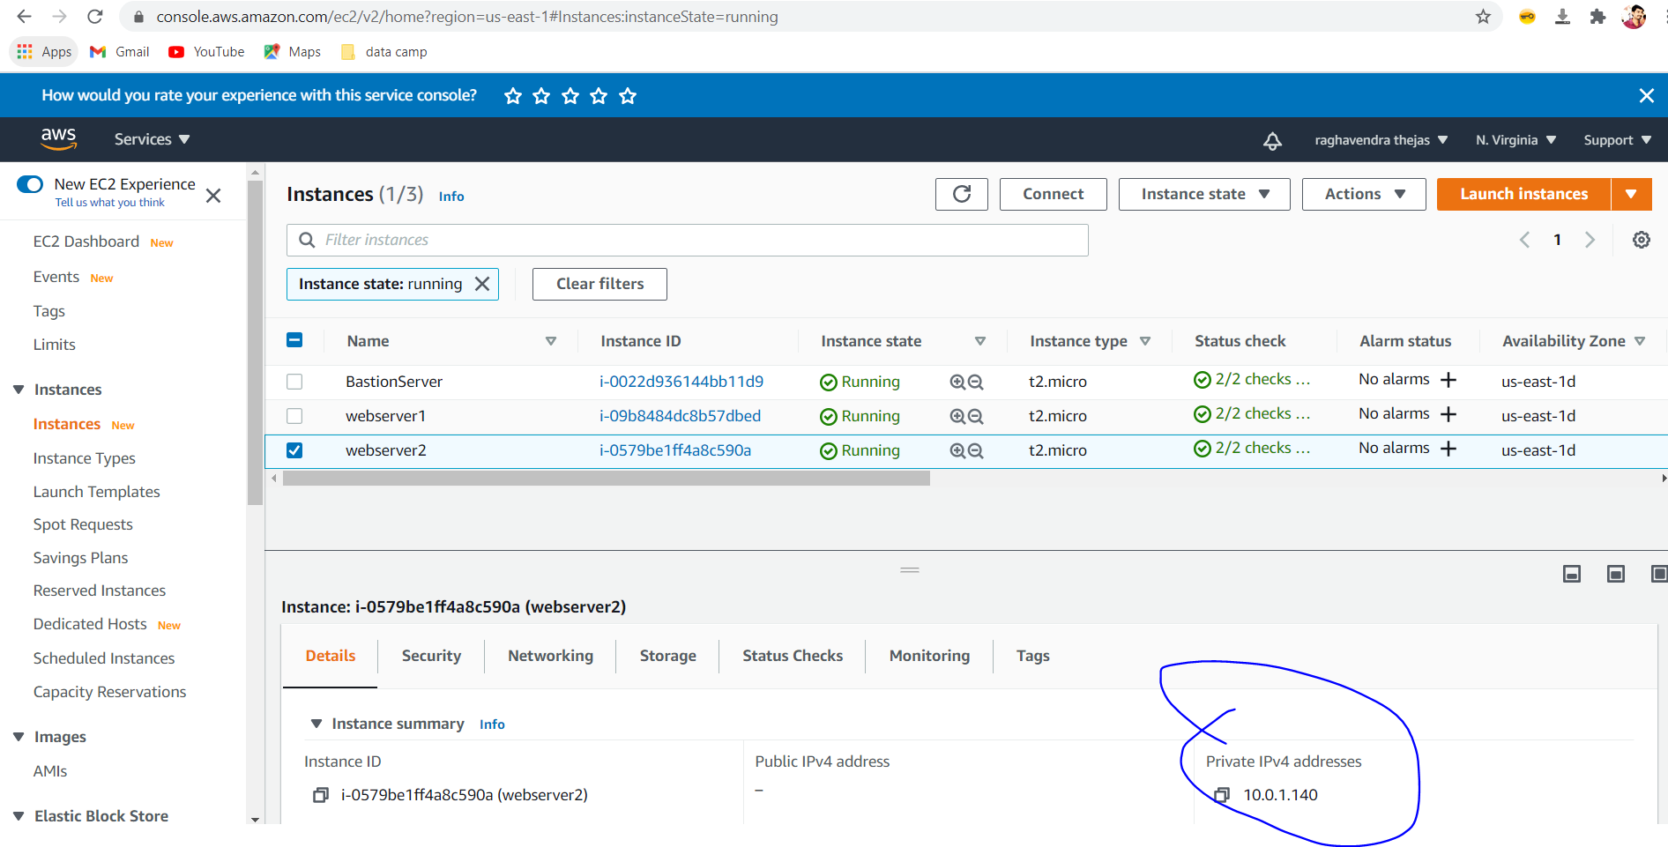

**9] Successfully created the load balancer**

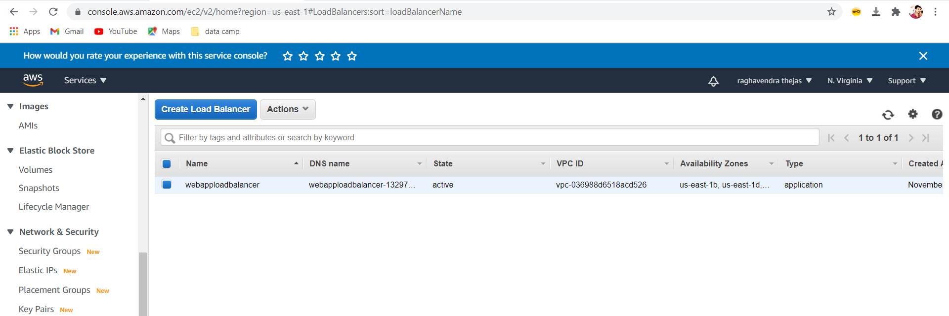

**10] Successfully able to login to bastion server and connected to webserver1**

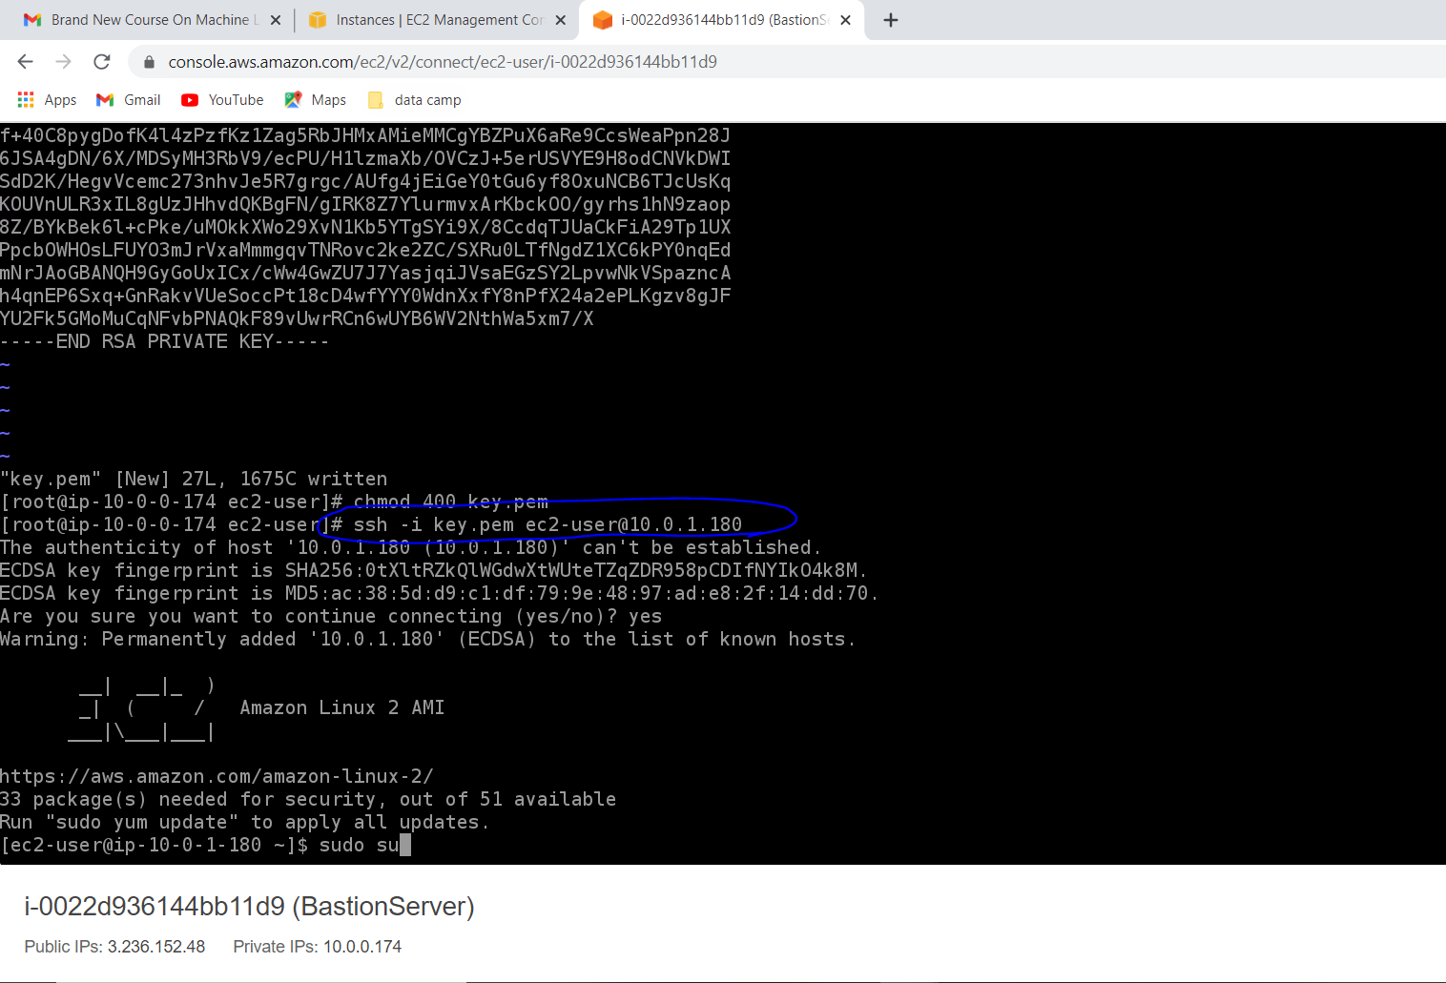

**Run all commands in webserver1 through bastion server**

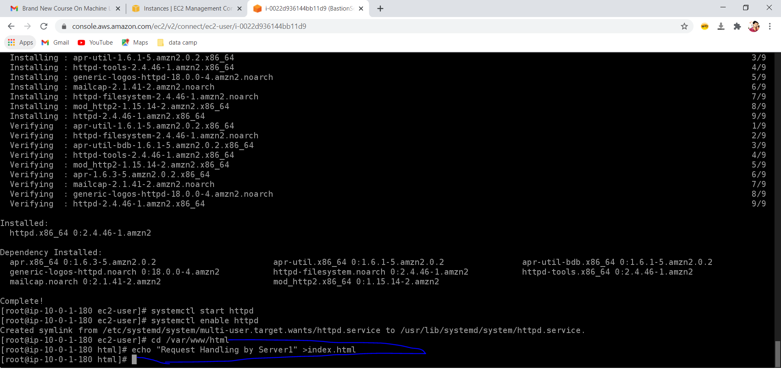

**11] Successfully able to login to bastion server and connected to webserver1**

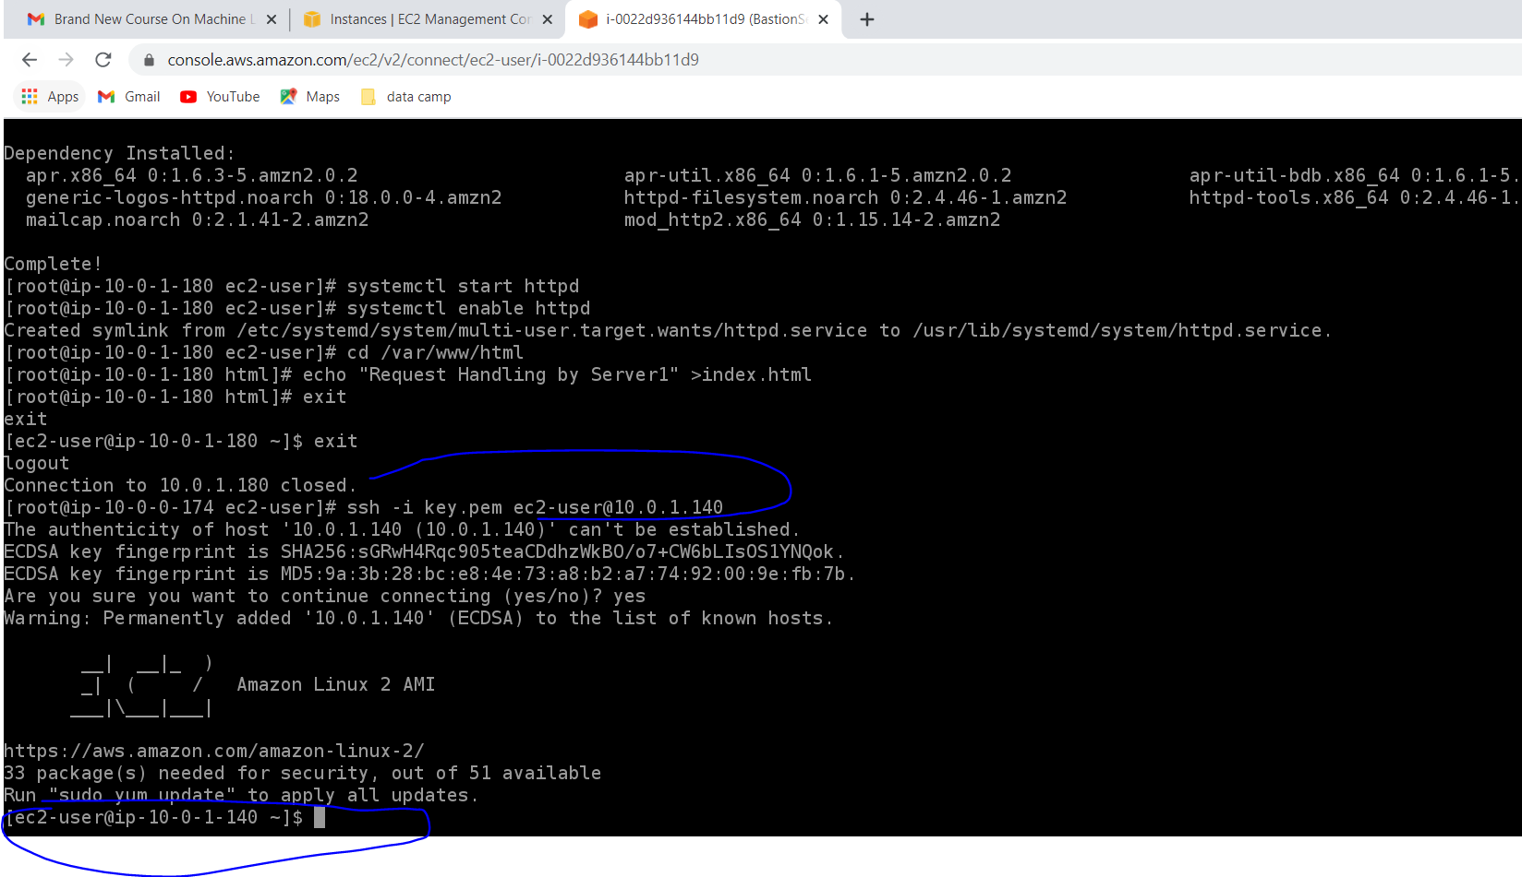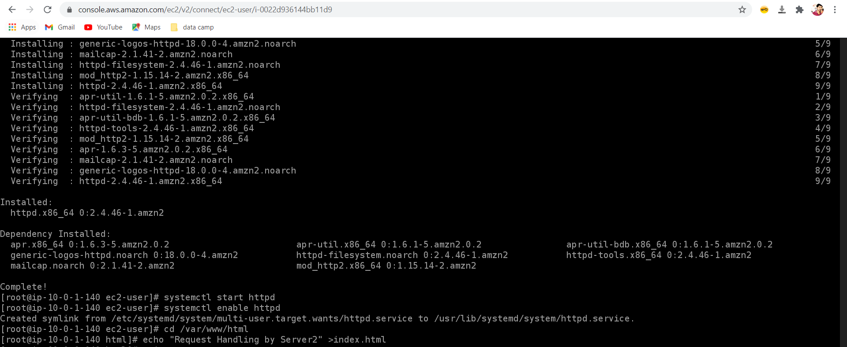

**12] Both servers**

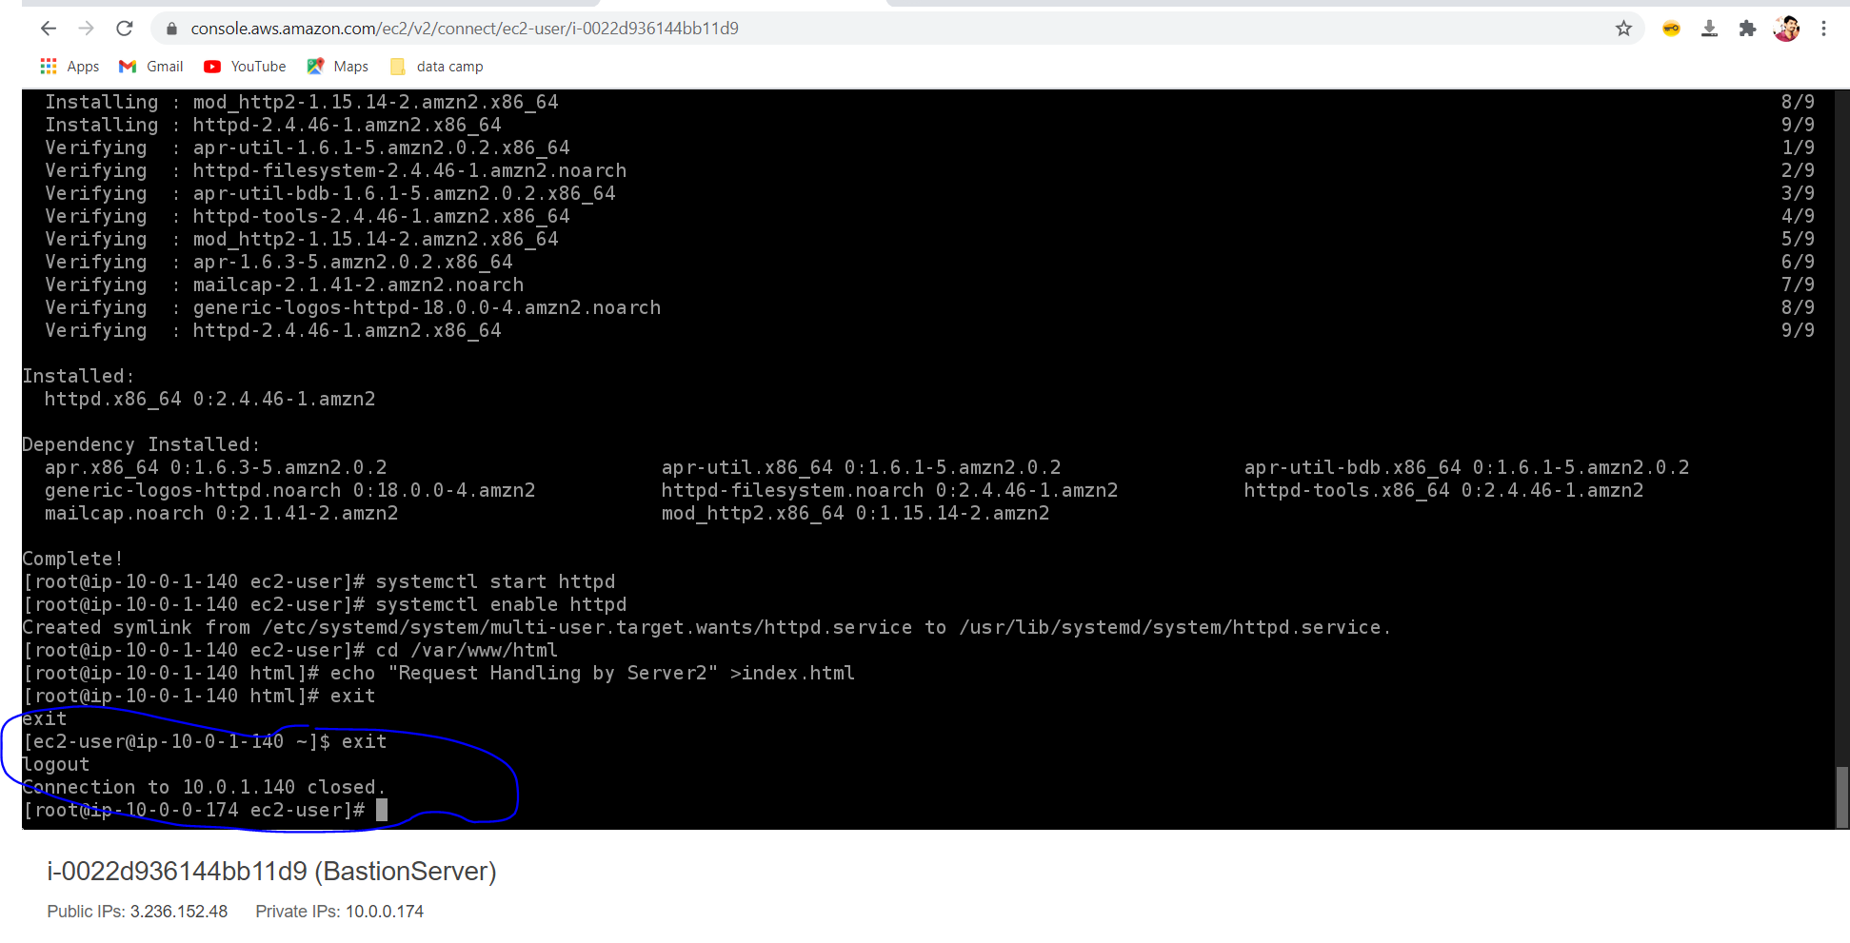

**13] Load balancer URL working perfectly using both webservers**

